**Fuselage shape**

**Airfoil shaped fuselages**

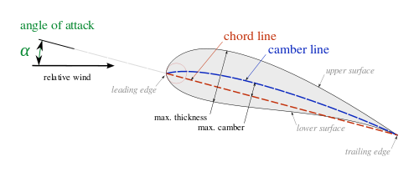

UAV’s, due to their small size and lower operating speed requires a larger lifting force, in order to maximize efficiency. Thus designing the craft with an airfoil shaped fuselage will greatly increase the lift capacity and efficiency (Alam and Islam, 2013).

**NACA 0015(symmetrical)**



Max thickness: 15% of chord line length @ x=30% of chord length

Length: 750mm

Max thickness: 112.5 mm @ x= 225 mm

Approx. Cockpit volume:

**Xfoil predictions**

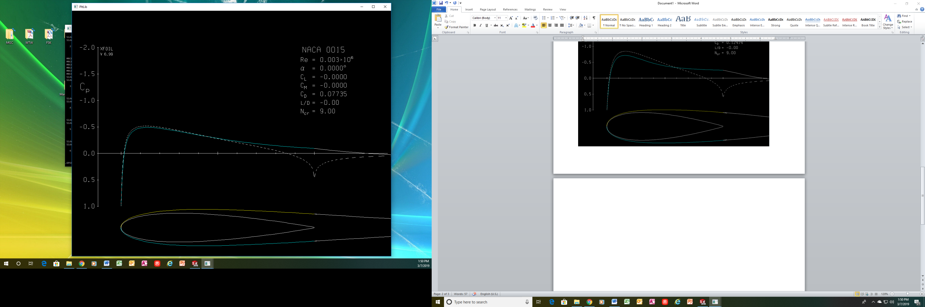

**Drag Coefficient: 7.7 %**

**Lift Coefficient: 0 %**

**Approx. cockpit volume : 300x80xZmm**

**NACA 0024(symmetrical)**

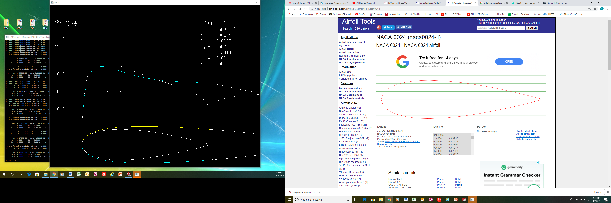

Max thickness: 24% of chord line length @ x=30% of chord length

Length: 750mm

Max thickness: 180 mm @ x= 225 mm

**Xfoil Predictions**

**Drag Coefficient : 12.4 %**

**Lift Coefficient: 0%**

**Approx. cockpit volume : 200x270xZmm**

**NACA 4415**

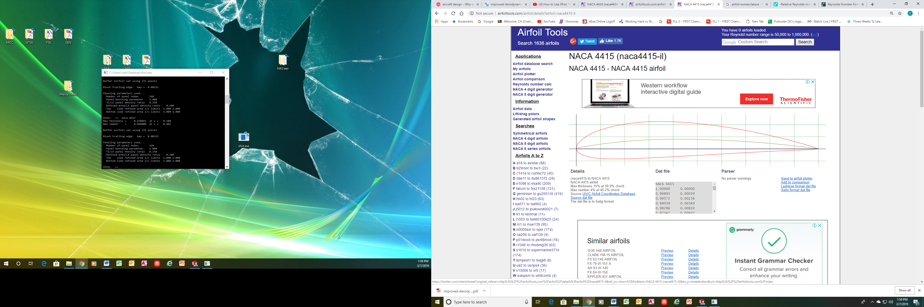

Max thickness: 15% of chord line length @ x=30% of chord length

Length: 750mm

Max thickness: 112.5 mm @ x= 225 mm

**Xfoil predictions**

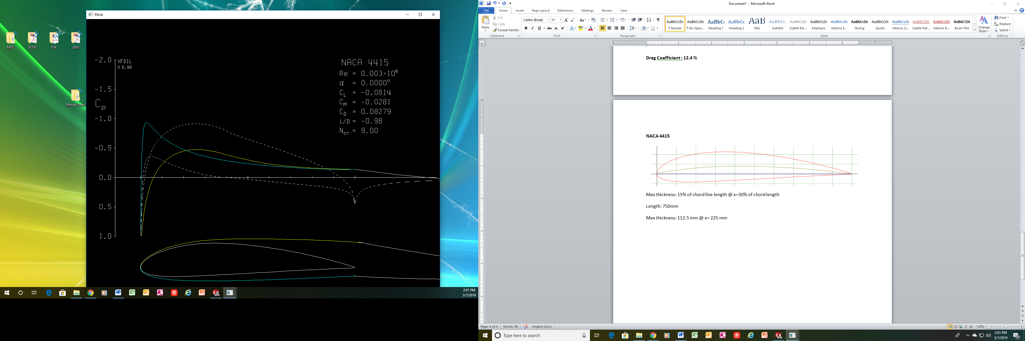

**Drag Coefficient: 8.28%**

**Lift Coefficient: 8.1%**

**Approx. cockpit volume: 240x80xZmm**

**NACA 4424**



Max thickness: 24% of chord line length @ x=30% of chord length

Length: 750mm

Max thickness: 180 mm @ x= 225 mm

**Xfoil Predictions**

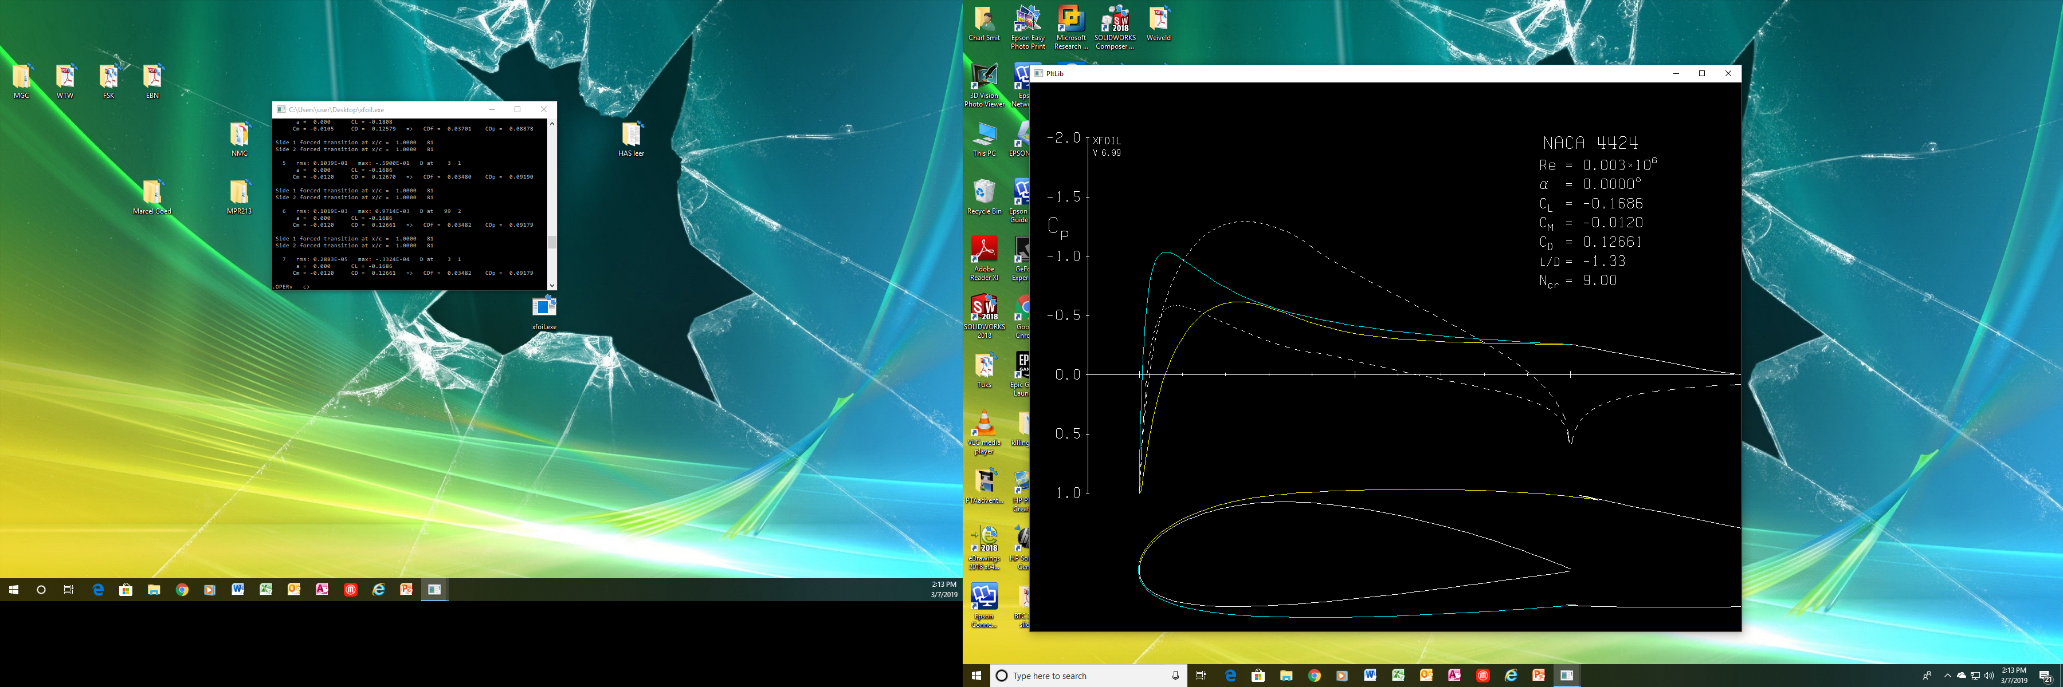

**Drag Coefficient : 12.6 %**

**Lift Coefficient: 16.8 %**

**Approx. cockpit volume : 200x150mm**

**References**

Alam, G. M. J. and Islam, A. K. M. S. (2013) ‘Improved Aerodynamic Characteristics of Aerofoil Shaped Fuselage than that of the Conventional Cylindrical Shaped Fuselage’, 4(1), pp. 1–9.